Experimental result of the Formula Electric Car Physical Parameters:

Current Array Plots from Dyno Data

(Spring ‘16)



Zainab Hussein

3-23-2017

# Hypothesis

Theoretically, both motor speed and torque have a linear relationship to current when either is held constant. Thus, experimental data should ideally show an array of linear relationships as shown in figure 1 and 2 for the case of changing power1.

Figure 1 Torque and current relation at constant RPM

Figure 2 RPM and current relation at constant torque

# Method

Raw data collected from the dynamometer was analyzed using Origin. The original data was extrapolated, specifically 1863 columns and 39 rows to form a matrix used to generate a contour 3D plot. Figure 3 shows current and motor speed relation when the contour plot is cut at constant values of torque. Figure 4 shows current and torque relation when the contour plot is cut at constant values of motor speed.

# Result

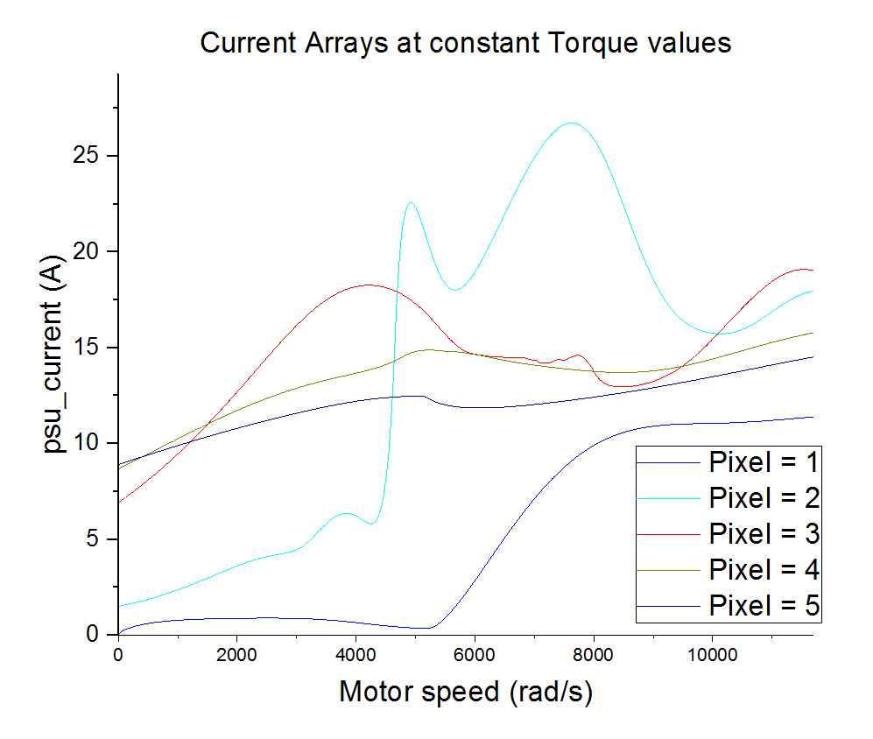

Figure 3 Current and motor speed at constant values of torque

## Table 1

|  |  |  |
| --- | --- | --- |
| Current at Constant Torque values | | |
|  | Actual Torque (Nm) | Approximate Torque (Nm) |
| Pixel 1 | 19.93 | 20 |
| Pixel 2 | 14.98 | 15 |
| Pixel 3 | 10.02 | 10 |
| Pixel 4 | 5.014 | 5 |
| Pixel 5 | 0.01191 | 0 |

Figure 32 shows a current array that is not consistent with the expected linear array. The range of current is 0 – 22A, which may not be sufficient to characterize a motor and motor controller system that goes to a max of 200A. Behavior under 1000 rad/s are transient as well.

The working range of our motor is a maximum of 200A current and 4500 rad/s motor speed, for that region except for plot at torque of 20 Nm, the rest of the plots depict some increase in current with increase in motor speed. The intersecting of some plots is not consistent with the expected single current and motor speed for a given torque.

A wider range of measurement would be the next step to realistically characterize the entire motor and motor controller system, and eliminate the suspicion of the current data depicting a transient behavior, rather than a steady state one.

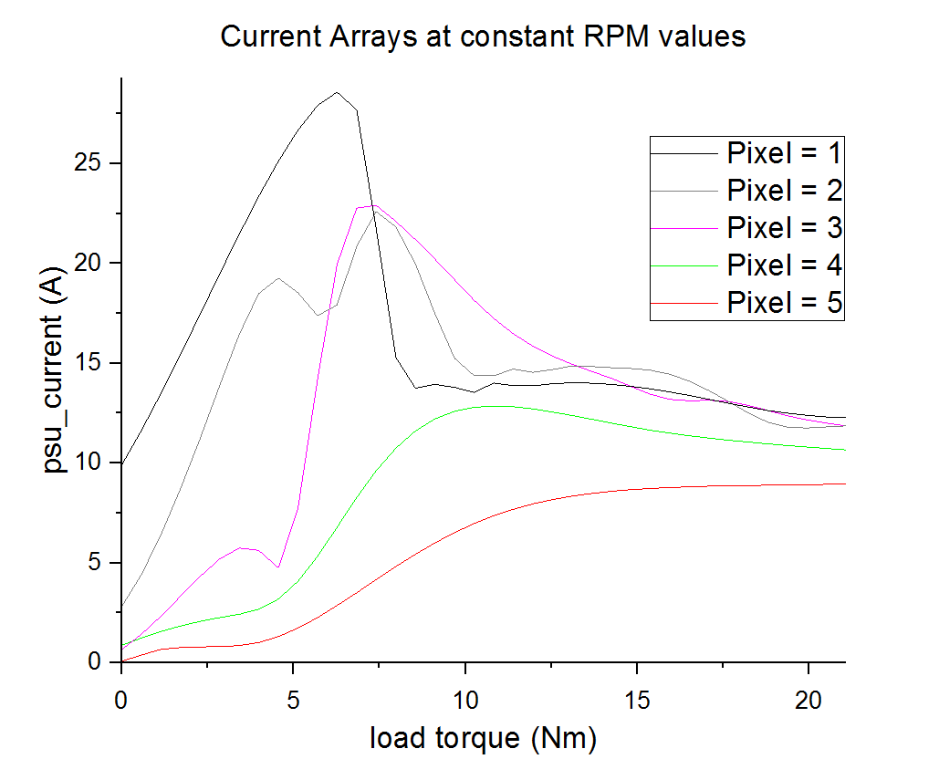

Figure 4 Current and torque at constant values of motor speed

## Table 2

|  |  |  |
| --- | --- | --- |
| Current at Constant RPM values | | |
|  | Actual RPM (rad/s) | Approximate RPM (rad/s) |
| Pixel 1 | 12.57 | 0 |
| Pixel 2 | 2012 | 2000 |
| Pixel 3 | 4004 | 4000 |
| Pixel 4 | 5993 | 6000 |
| Pixel 5 | 7999 | 8000 |

Figure 42 shows a current array that is not consistent with the expected linear array. The initial values of torque seem to have some linear relation with current but seem to reach an optimum level before decreasing. The range of current is 0 – 22A, which may not be sufficient to characterize a motor and motor controller system that goes to a max of 200A. Behavior under 1000 rad/s are transient as well.

A wider range of measurement would be the next step to realistically characterize the entire motor and motor controller system, and eliminate the suspicion of the current data depicting a transient behavior, rather than a steady state one.

# References:

1Theoretical relation of the formula Electric Car Physical Parameters of Load Torque, Supply Current and Motor Speed.

2Plotting 3D surfaces in Origin: <http://wiki.originlab.com/~originla/howto/index.php?title=Tutorial:3D_Plotting>

<http://www.originlab.com/index.aspx?go=Products/Origin/Graphing>